|  |  |
| --- | --- |
| **Name** | Muhammad Asad |
| **Roll no.** | 2019-EE-383 |
| **Section** | A-G1 |



***Programming Fundamentals***

**Lab # 5**

* **Objectives:**
* The First objective of this lab is to learn to take input from the user.
* The second objective of this lab is to learn the concept of if/else statement.
* The third objective of this lab is to learn arithmetic operations using different data types.
* **Task # 1:**

• Prompt the user to enter three integers.

• State whether these three integers can be the sides of a right angled triangle.

* **Code:**

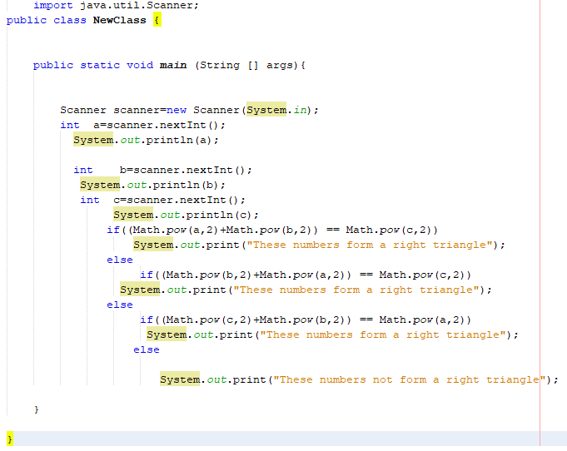

* **Output:**

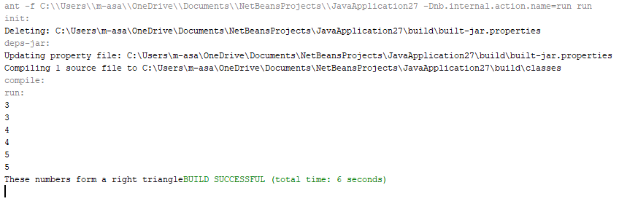

* **Task # 2:**

• Write a program that asks a user to enter his/her age and prints whether the user is a kid, teenager or an adult using if-else statement.

Age 0-12 = Kid

Age 13-18 = Teenage

Age >18 = Adult

* **Code:**

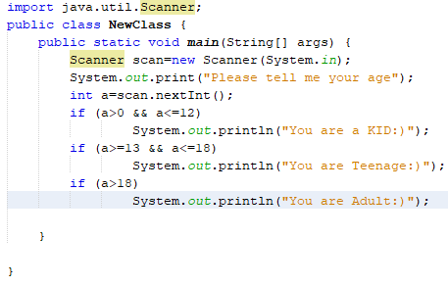

* **Output:**

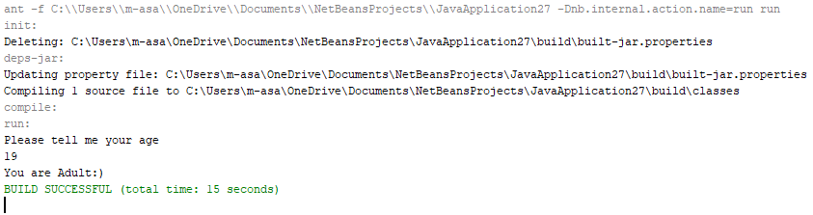

* **Task # 3:**

• Develop a basic calculator using if-else statement which is capable of performing addition, subtraction, multiplication and division.

Hint 1: Ask the user to enter two numbers and the type of arithmetic operation to be performed.

Hint 2: Use char data type for the variable handling the operation type.

* **Code:**

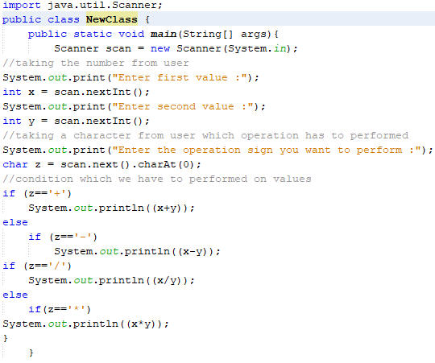

* **Output:**

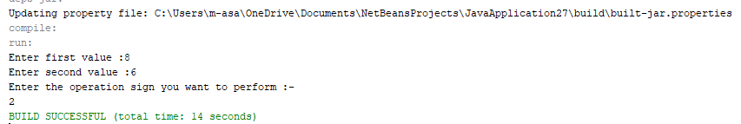

* **Task # 4:**

• Take 5 integers from the user.

• Find out the maximum and the minimum number of the five and print them on the screen.

* **Code:**

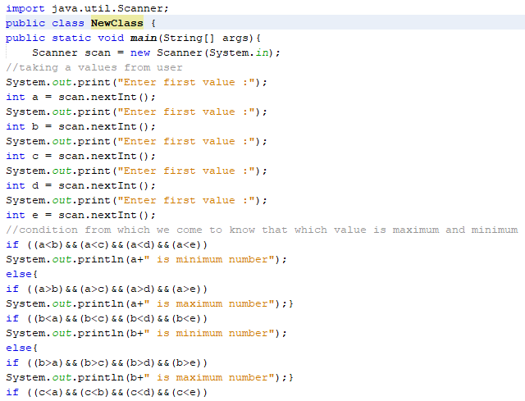

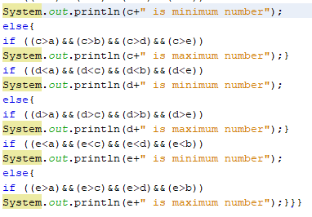

* **Output:**

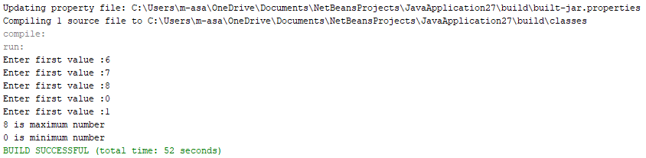

* **Task # 5:**

• Write a C program to accept a coordinate point in a XY coordinate system and determine in which quadrant the coordinate point lies

* **Code:**

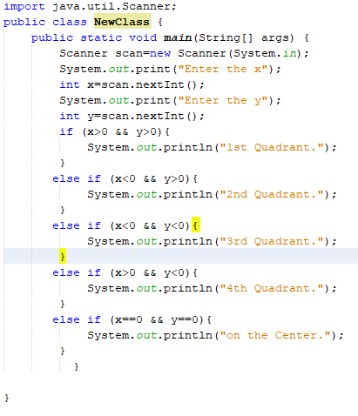

* **Output:**

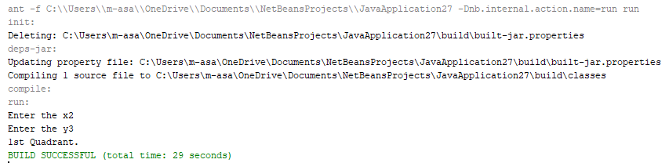

* **Conclusion:**
* In this lab, I learnt to take input from user using scanner class and performing the programs in very efficient way.
* If Boolean expression comes to be true then if block executes otherwise else statement will be executed.
* If / else statements are very much important in writing a program.